PIZZA SALES SQL QUERIES
- Total Revenue
SELECT SUM (TOTAL_PRICE) AS TOTAL_REVENUE FROM pizza_sales1;
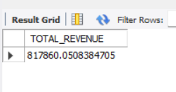
- Average Order Value
SELECT SUM(TOTAL_PRICE) / COUNT(DISTINCT ORDER_ID) AS AVG_ORDER_VALUE FROM pizza_sales1;
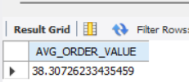
- Total Price Sold
SELECT SUM(QUANTITY) AS TOTAL_PRICE_SOLD FROM pizza_sales1;
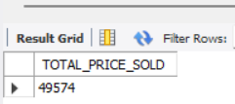
- TOTAL ORDERS
SELECT COUNT(DISTINCT ORDER_ID) AS TOTAL_ORDER FROM pizza_sales1;
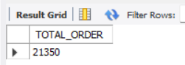
- AVERAGE PIZZA PER ORDER
SELECT CAST(CAST(SUM(QUANTITY) AS DECIMAL (10,2)) /
CAST(COUNT(DISTINCT ORDER_ID ) AS DECIMAL (10,2)) AS DECIMAL(10,2)) FROM pizza_sales1;
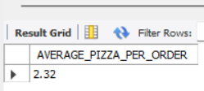
- DAILY TREND FOR TOTAL ORDERS
SELECT DAYNAME(order_date) AS order_day, COUNT(DISTINCT order_id) AS total_orders
FROM pizza_sales1 WHERE order_date IS NOT NULL GROUP BY DAYOFWEEK(order_date), DAYNAME(order_date) ORDER BY DAYOFWEEK(order_date);
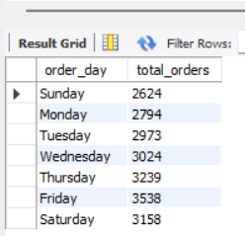
- MONTHLY TREND FOR TOTAL ORDERS
SELECT
MONTHNAME(order_date) AS month_name,
COUNT(DISTINCT order_id) AS total_orders
FROM pizza_sales1
WHERE order_date IS NOT NULL
GROUP BY MONTH(order_date), MONTHNAME(order_date)
ORDER BY MONTH (order_date) ;
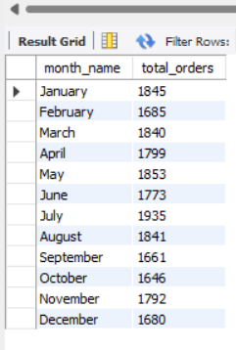
- PERCENTAGE OF SALES BY PIZZA CATEGORY
SELECT PIZZA_CATEGORY, SUM(total_price) * 100 / (SELECT SUM(total_price) FROM pizza_sales1) AS PERCENTAGE _ SALES FROM pizza_sales1 GROUP BY pizza_category;
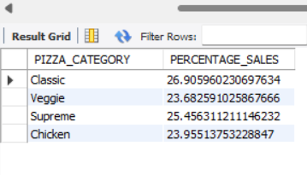
- SAME 8 NO WORK BUT ITS FIND MONTH WISE :-
SELECT PIZZA_CATEGORY, SUM(total_price) * 100 / (SELECT SUM(total_price)
FROM pizza_sales1) AS PERCENTAGE_SALES
FROM pizza_sales1
WHERE month(ORDER_DATE)=5
GROUP BY pizza_category;
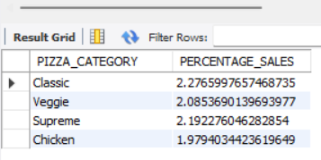
HERE MONTH(ORDER_DATE)=1 INDICATES THAT THE OUTPUT IS FOR THE MONTH OF JANUARY . MONTH(ORDER_DATE) = 4 INDICATE OUTPUT FOR MONTH OF APRIL.
- PERCENTAGE OF SALES BY PIZZA SIZE
SELECT PIZZA_SIZE, CAST(SUM(total_price) AS decimal(10,2)) AS TOTAL_SALES, CAST(SUM(total_price) * 100 / (SELECT SUM(total_price)
FROM pizza_sales1) AS DECIMAL(10,2)) AS PERCENTAGE_SALES
FROM pizza_sales1
GROUP BY PIZZA_SIZE
ORDER BY PERCENTAGE_SALES DESC;
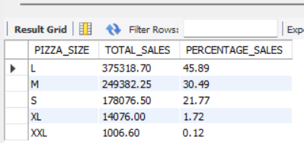
- TOP 5 BEST SELLERS BY REVENUE , TOTAL QUANTITY AND TOTAL ORDERS
SELECT PIZZA_NAME, CAST(SUM(TOTAL_PRICE) AS DECIMAL(10,2)) AS TOTAL_REVENUE FROM PIZZA_SALES1 GROUP BY PIZZA_NAME
ORDER BY TOTAL_REVENUE DESC LIMIT 5;
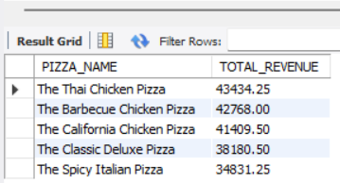
- BOTTOM 5 PIZZA SELLES REVANUE :-
SELECT PIZZA_NAME, CAST(SUM(TOTAL_PRICE) AS DECIMAL(10,2)) AS TOTAL_REVENUE FROM PIZZA_SALES1 GROUP BY PIZZA_NAME
ORDER BY TOTAL_REVENUE ASC LIMIT 5;
SELECT PIZZA_NAME, CAST(SUM(TOTAL_PRICE) AS DECIMAL(10,2)) AS TOTAL_REVENUE FROM PIZZA_SALES1 GROUP BY PIZZA_NAME
ORDER BY TOTAL_REVENUE ASC LIMIT 5;
- TOP 5 QUANTITY PIZZA
SELECT PIZZA_NAME,SUM(QUANTITY) AS TOTAL_QUANTITY FROM PIZZA_SALES1 GROUP BY PIZZA_NAME
ORDER BY TOTAL_QUANTITY DESC LIMIT 5;
